**EXPERIMENT 2**

**Study of Digital Storage Oscilloscope**

**Objectives:**

1. To become familiar with the operation and adjustment of controls on the front panel of a DSO.

2. To use the DSO for visual display of electrical signals.

3. To make frequency measurement by means of Lissajous patterns.

4. To measure the phase difference between two signals of the same frequency.

5. To learn how to measure the period and frequency of a periodic waveform.

**Apparatus Required:**

1. Digital Storage oscilloscope

2. DC power supply 0-30V

3. Function generator 0 to 3 MHz

4. Resistors and capacitors

**Introduction to DSO:**

The Digital Storage Oscilloscope (DSO) is an extremely useful and versatile laboratory instrument useful for measurement and analysis of waveforms and other phenomena in electrical and electronic circuits. An oscilloscope automatically graphs a time varying voltage, that is, it displays the instantaneous amplitude of any voltage waveform versus time. Most applications for oscilloscopes are to plot periodic signals. However, the DSO can capture (store and display) transient signals as well, with appropriate triggering.

In addition to voltages, the DSO can visually represent many time varying quantities with the help of "transducers" or sensors that convert current, pressure, strain, acceleration, temperature etc. into voltages.

As pointed out earlier, the oscilloscope is designed to plot periodic signals.

**Theory:**

The Digital Storage Oscilloscope (DSO) is an extremely useful and versatile laboratory instrument useful for measurement and analysis of waveforms and other phenomena in electrical and electronic circuits. An oscilloscope automatically graphs a time varying voltage, that is, it displays the instantaneous amplitude of an a. c. voltage waveform versus time. In addition to voltages, the CRO can present visual representation of many time varying quantities by means of “transducers” which convert current, pressure, strain, acceleration, temperature etc. into voltages.

**Experimental Setup:**

The oscilloscope is divided into various sections which are as follows;

Section 1 – The five function keys located on the side of the display

Section 2 – The section below the display consisting of Power switch, and probe compensation output (calibrated source).

Section 3 – A variable knob and Ten Menu keys located on the top side to the left of the display.

Section 4 – Knobs and buttons located in three columns at the center part, indicated as: VERTICAL, HORIZONTAL, and TRIGGER.

Section 5 – Located at the bottom part to the left of the display are input BNC sockets for CH -1, CH - 2 and External Trigger terminals, and an extra socket for GND.

DSO operations require the use of a combination knobs and buttons.

a) Channels CH -1 and CH-2

b) CH-1 and CH-2 Coupling Modes: The three possible coupling modes are DC (two lines: solid line and broken line), AC (sine wave), and GROUND (ground sign). As you press this function key the coupling modes keep changing. The present mode would be displayed below the “Coupling” function.

c) Triggering the display: Proper triggering of the signal is required to get a stable display.

d) Horizontal Functions

e) Horizontal time base (Y-T, X-Y, or Roll)

f) AUTOSCALE Function

1. **Voltage measurement:**

Connect the function generator to the DSO's channel 1. In the function generator, set the signal to sine wave. Change the amplitude of the signal and measure its peak-to-peak voltage using DSO and tabulate the readings. Make sure the Volts/Per division is highest possible for the given signal. Measure the signal using the markings on the oscilloscope. You may optionally use the cursor feature to give you an accurate reading. Along with the reading, estimate an upper bound for the possible error in measurement.

**Observations:**

|  |  |  |  |
| --- | --- | --- | --- |
| **Reading in division** | **Volts/division setting** | **VP-P (calculated) (V)** | **RMS value(calculated)(V)** |
| 3.96 | 1 | 3.96 | 1.40 |
| 6.16 | 1 | 6.16 | 2.18 |
| 4.08 | 2 | 8.16 | 2.88 |
| 6.45 | 0.2 | 1.29 | 0.46 |
| 3.16 | 5 | 15.80 | 5.59 |

Photos of Waveforms:

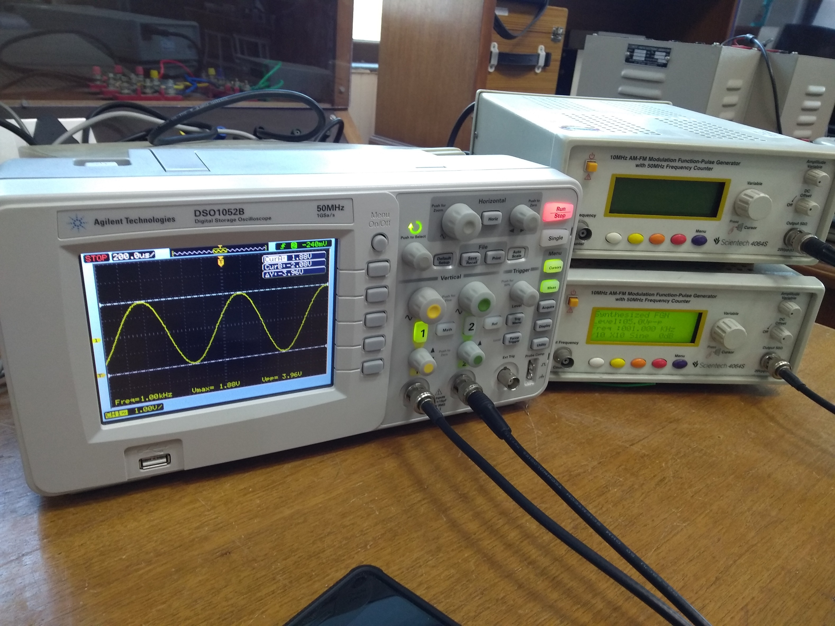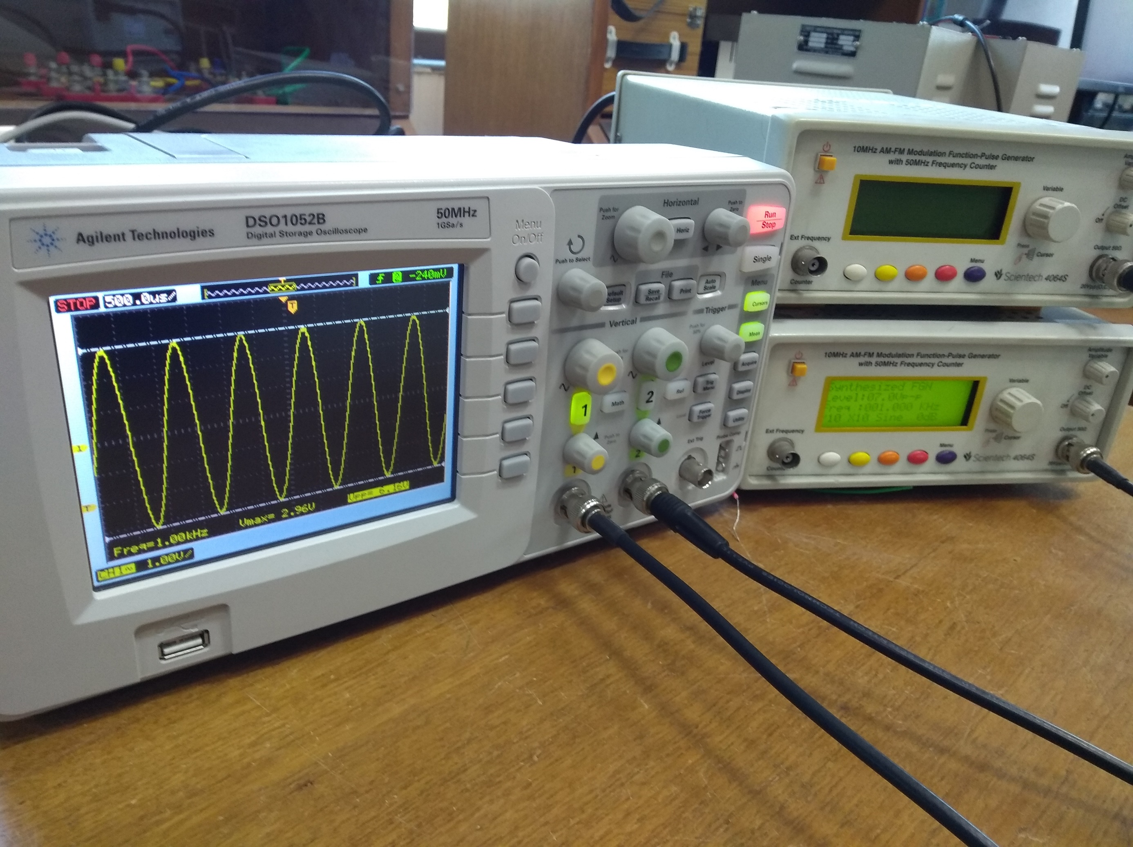

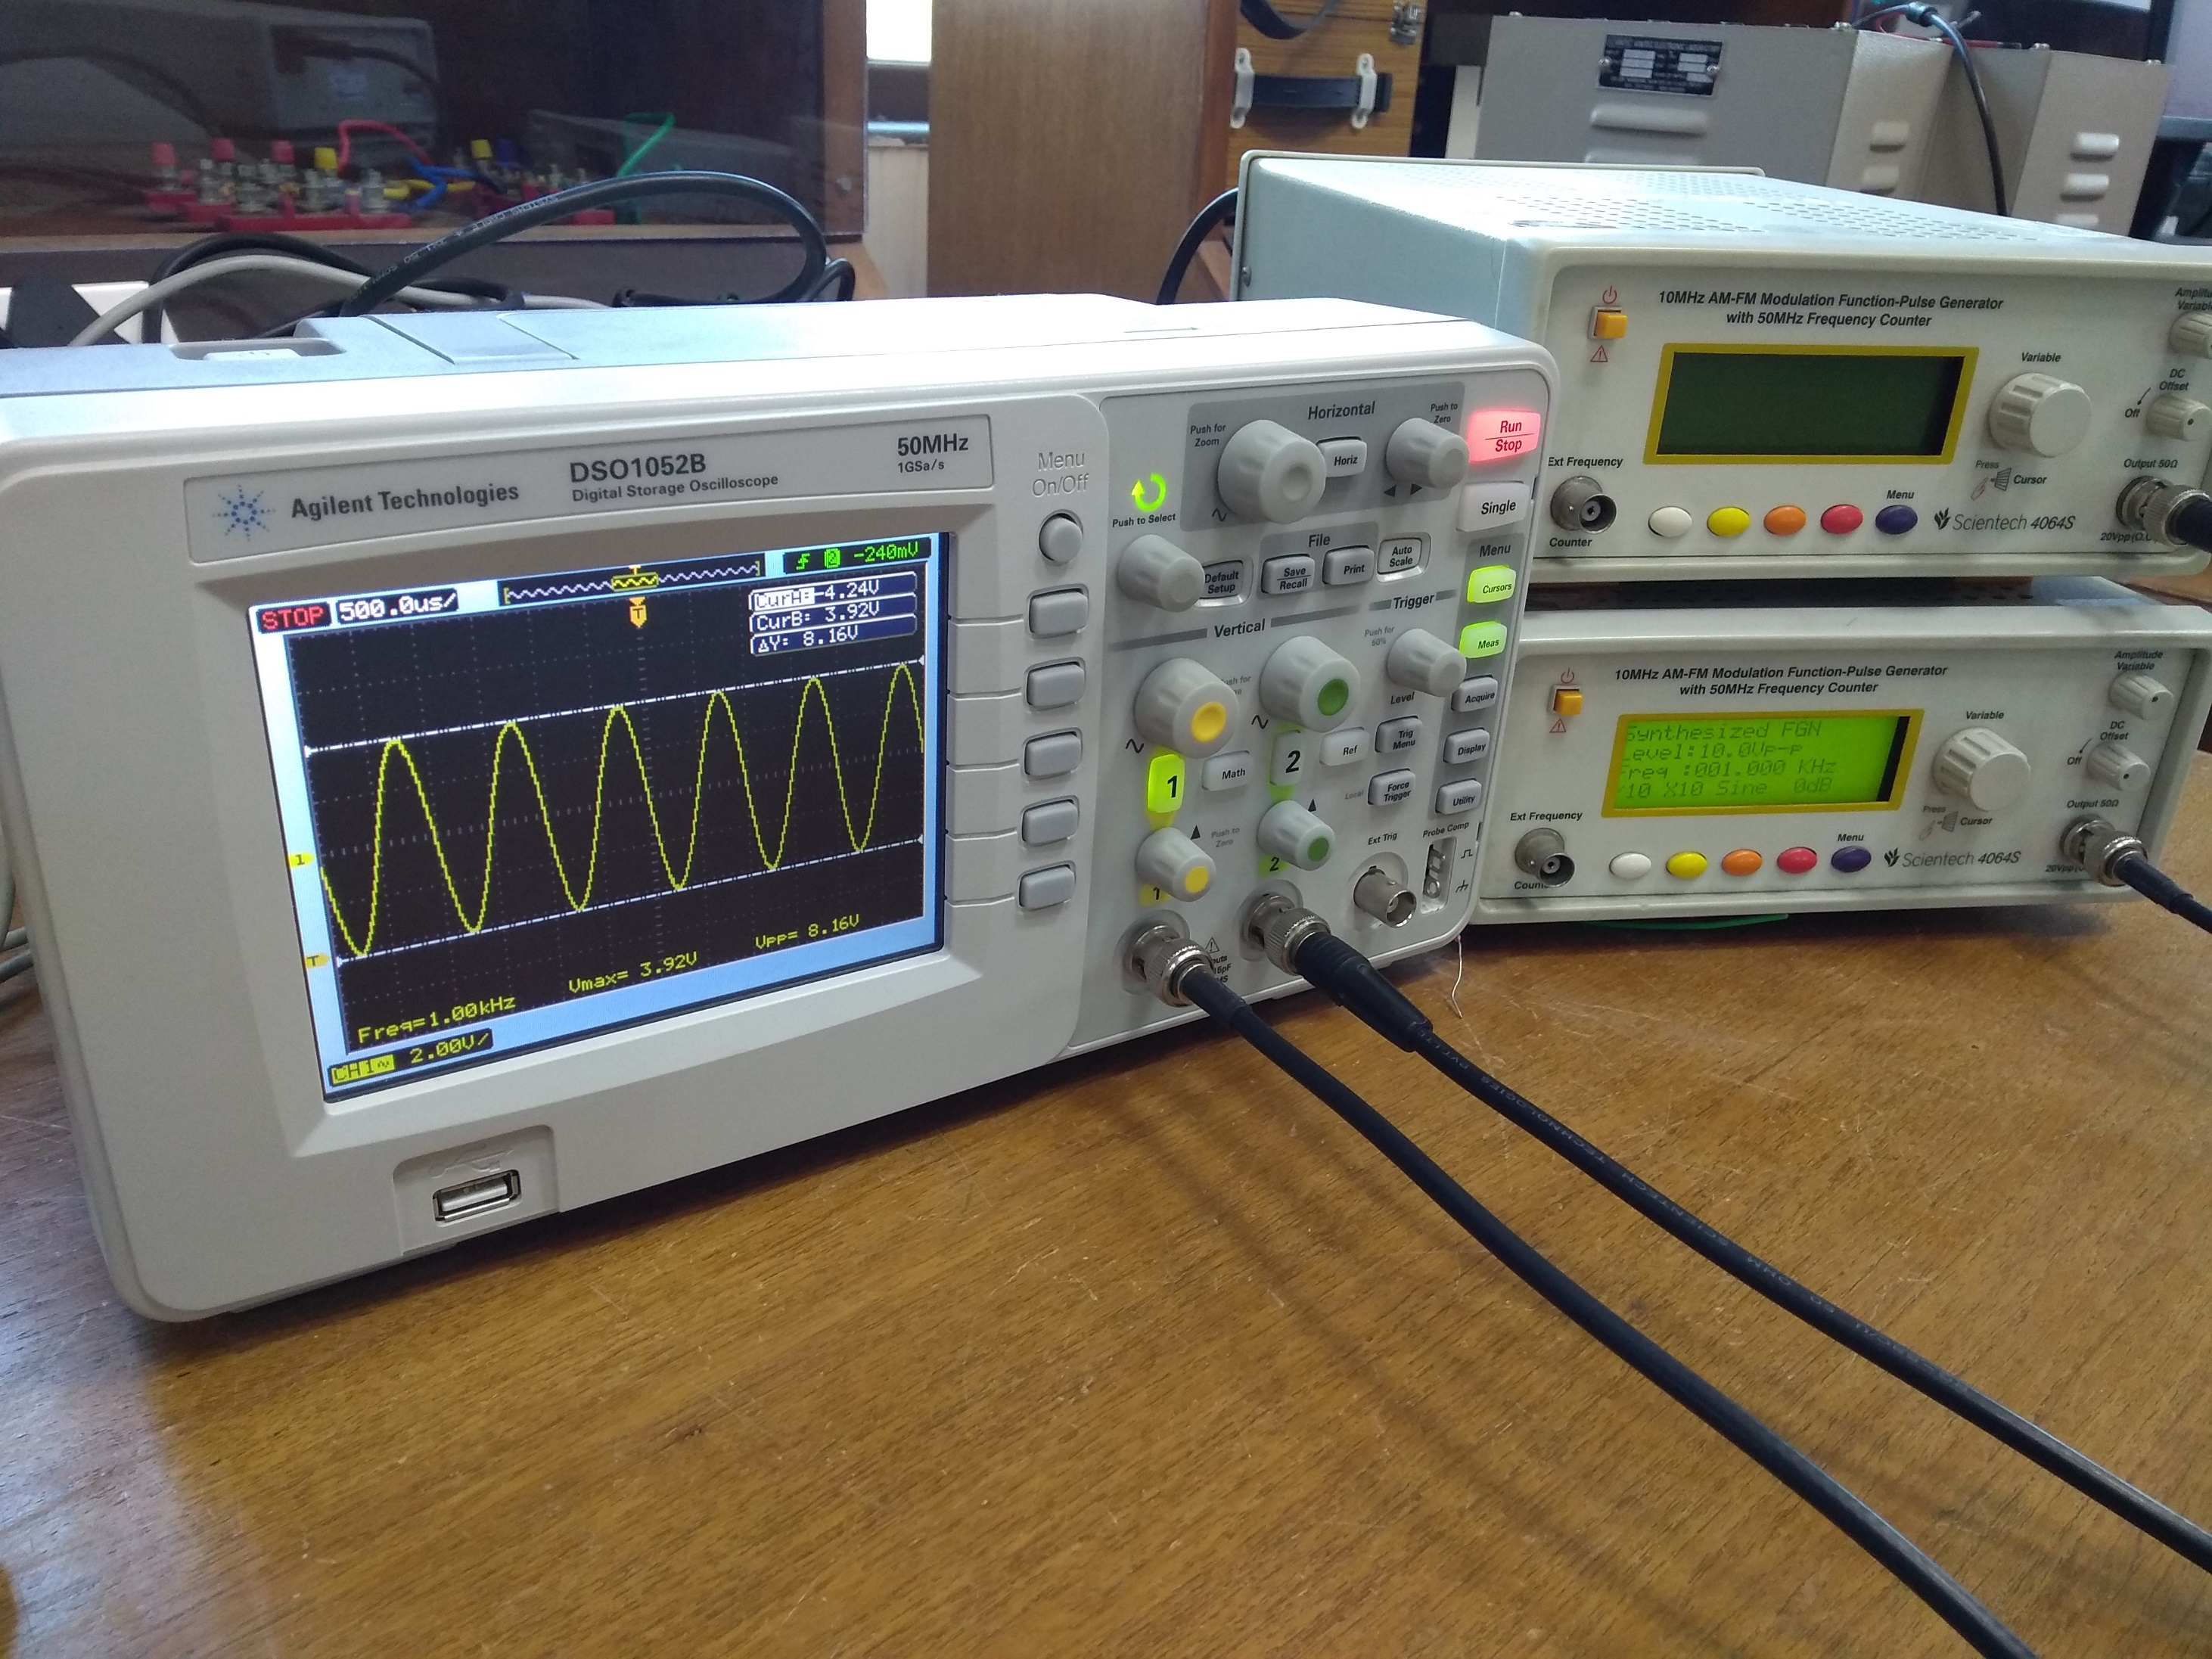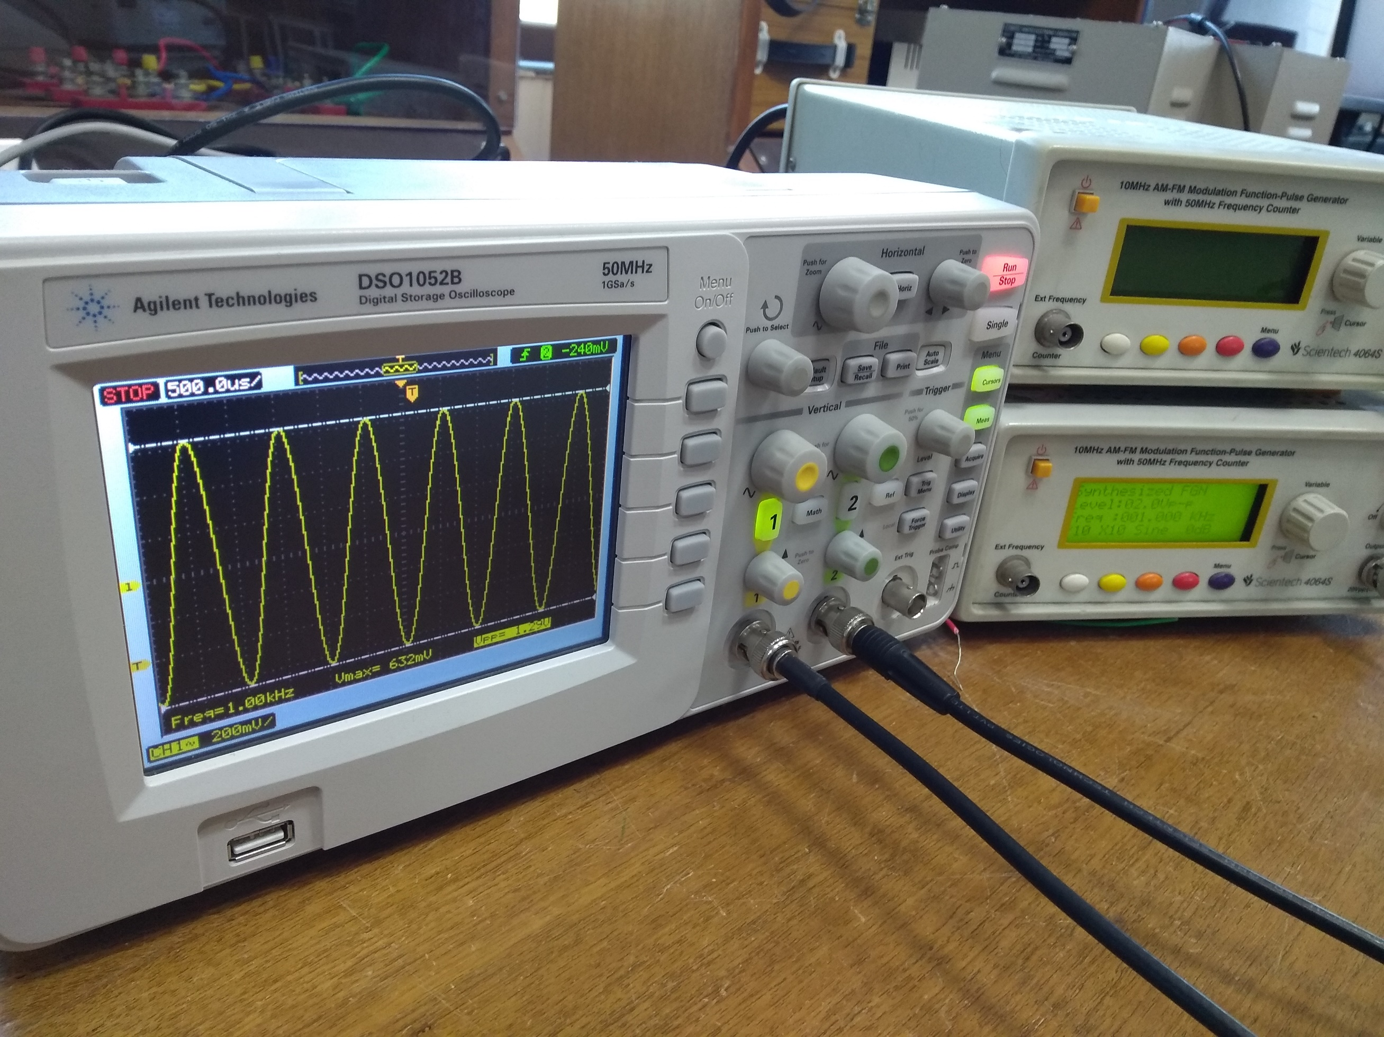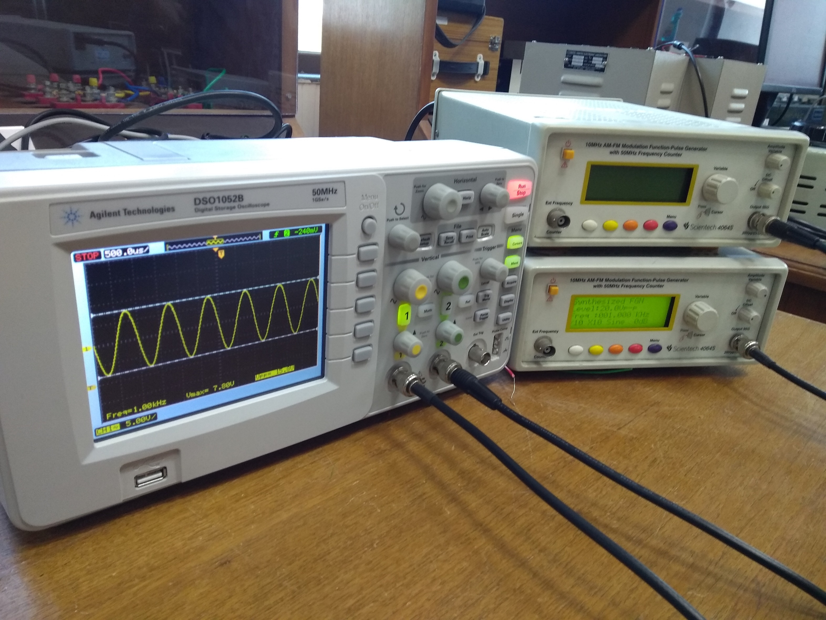

1. **Frequency Measurement :**

The unknown frequency signal is usually applied to the vertical terminal of the oscilloscope and the standard frequency signal is applied to the horizontal amplifier. The horizontal time-base mode should be set to XY mode. The standard frequency is then adjusted manually until the pattern appears as a circle or ellipse, indicating that both signals are at the same frequency. Where it is not possible to adjust the standard signal frequency to the exact frequency of the unknown signal, the standard is adjusted to a multiple until a stable pattern appears on the screen. This is called a Lissajous pattern. Several Lissajous patterns are to be observed. Note that if a horizontal (H) and a vertical (V) lines are drawn tangent to the figure, the number of points of horizontal tangency, TH and vertical tangency TH may be obtained. The relationship between the known signal frequency and the unknown signal frequency Fx is given by the equation.

Fx = F. TH/TV

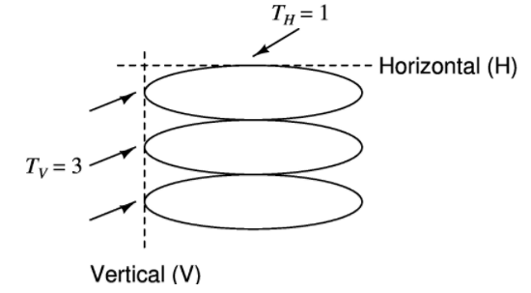

**Observations:**

|  |  |  |  |  |
| --- | --- | --- | --- | --- |
| **Lissagous Pattern** | **TH** | **TV** | **Frequency of generator (KHz)** | **Unknown Frequency**  **(KHz)** |
|  | 1 | 1 | 1 | 1 |
|  | 5 | 2 | 2 | 5 |
|  | 4 | 5 | 5 | 4 |
|  | 2 | 1 | 2 | 4 |

Photos of Lissagous Pattern:

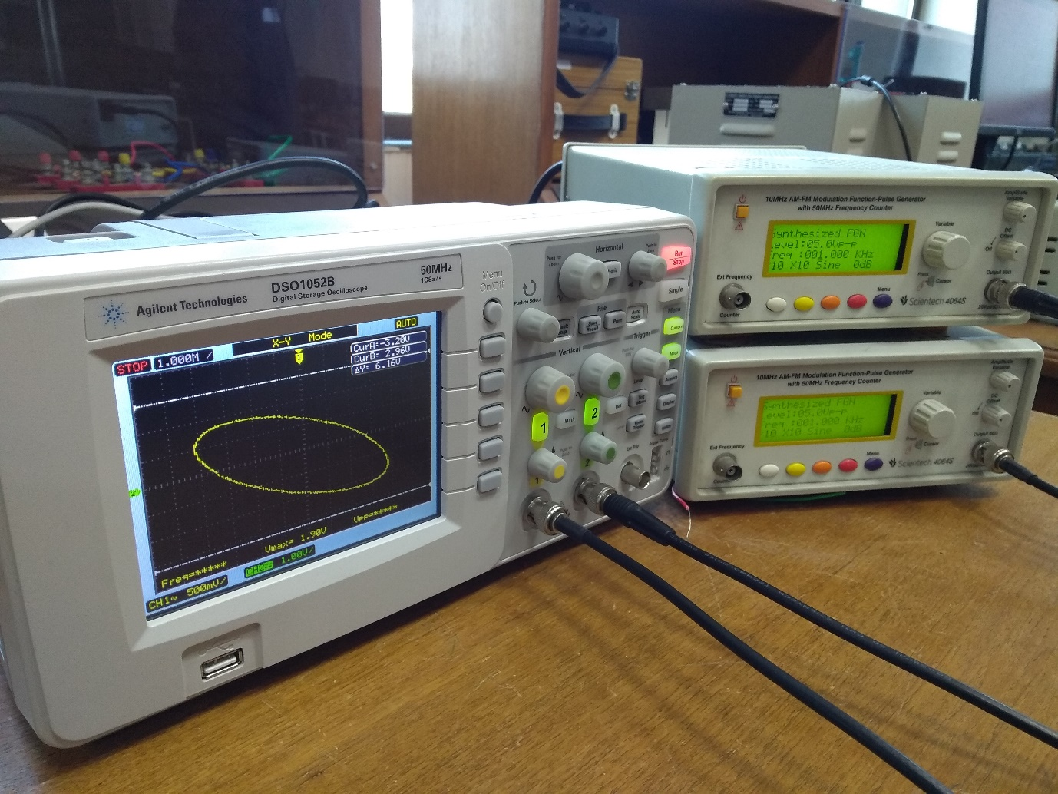

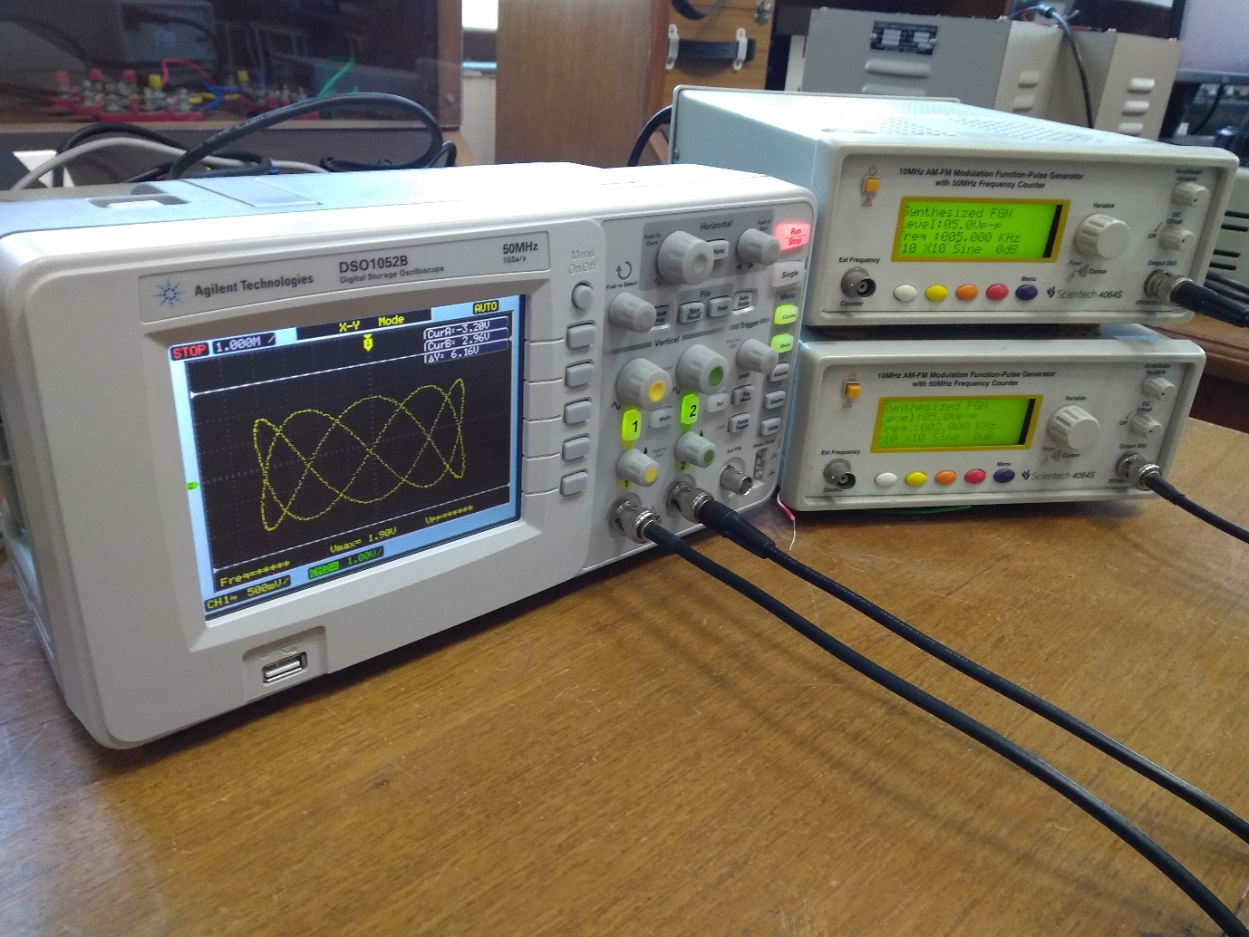

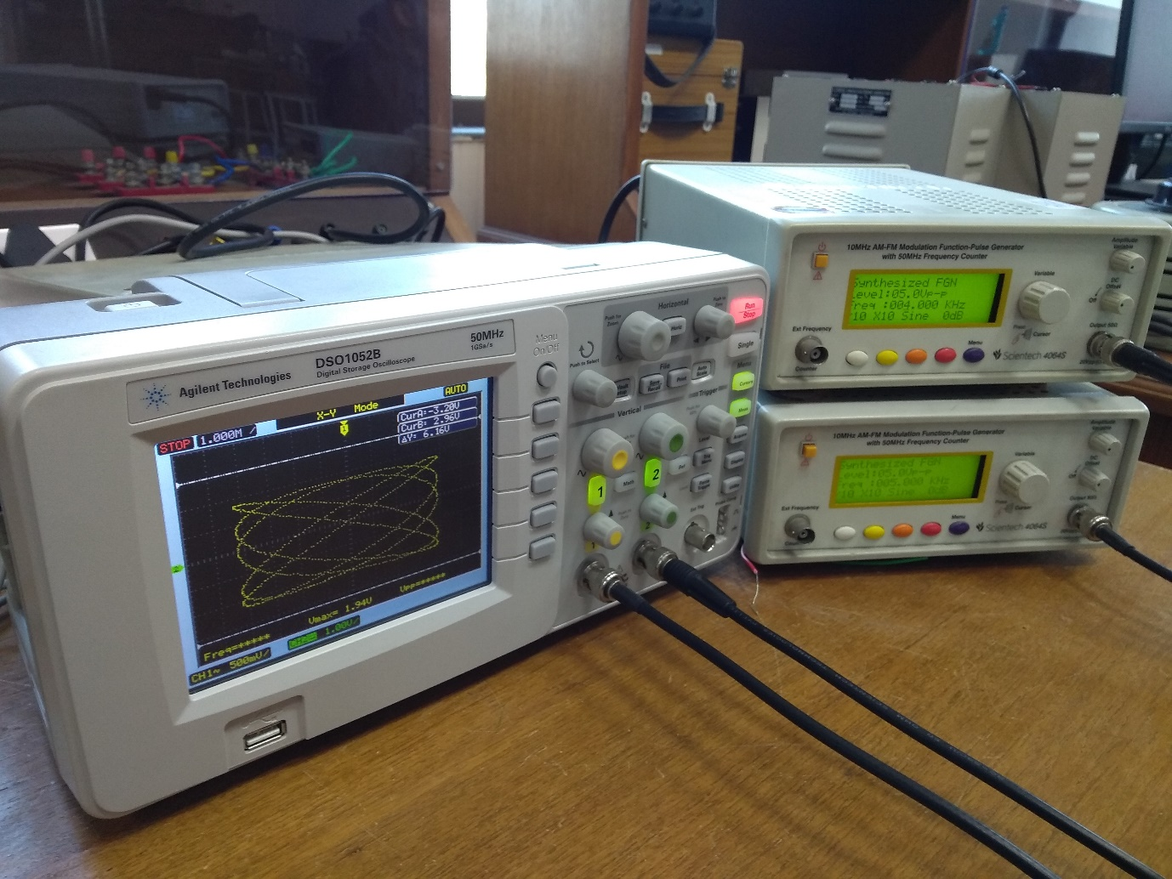

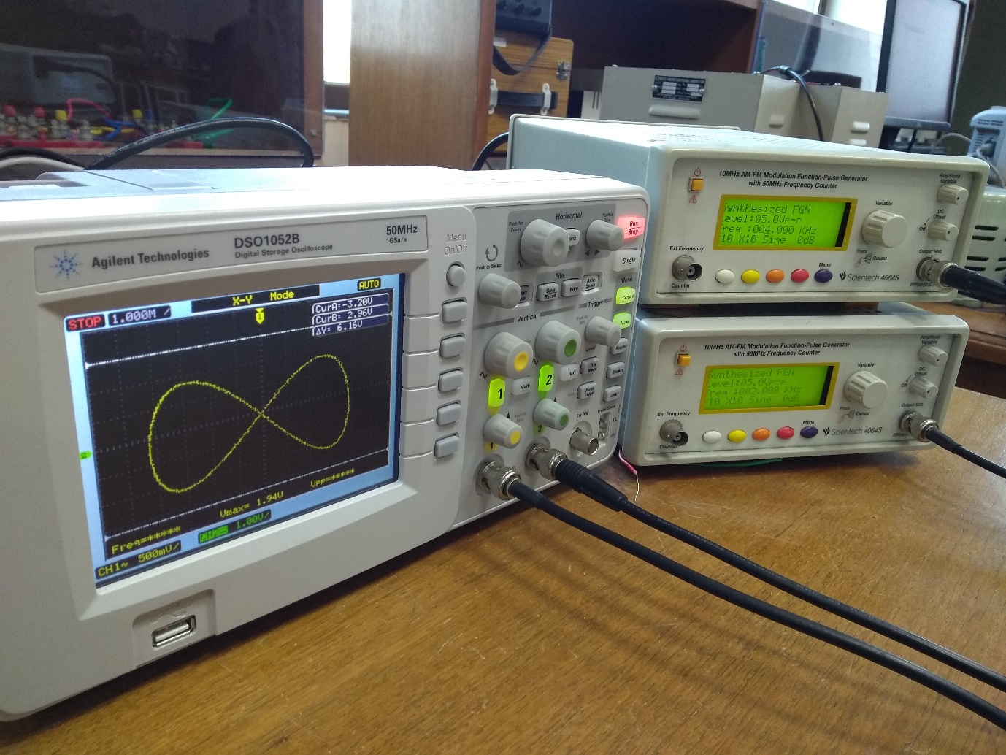

1. **Phase Measurement :**

Connect the circuit as shown in Figure. Set the frequency of the signal generator at 1KHz and voltage at 4-volt peak to peak. Point A goes to the horizontal (Ch. II) input terminal point, Point B goes to the vertical (Ch. I) input terminal point and G to the ground of the Oscilloscope. Switch on the CRO and set it to XY mode. Ground both the channels and adjust the beam into the center of the CRO screen. Remove the set ground from both the channels to get an elliptical pattern on the screen of CRO. The value of R can be varied from 0 Ω to 10 KΩ in step by using a variable resistance. Calculate the phase difference, which may be computed by substituting measured values of A and C in the formula sin θ = C/A.

Verify the experimental result with the calculated value by substituting the values of XC and R in the equation. tan θ = XC/R where XC is the capacitive reactance of C.

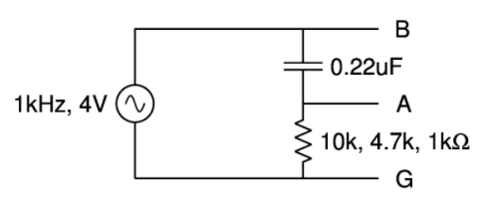

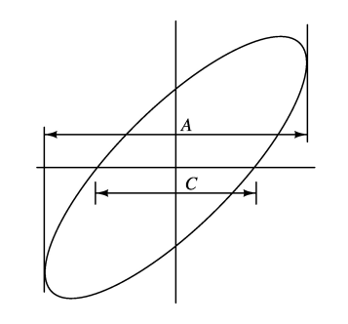

**Observations:**

|  |  |  |  |  |  |  |
| --- | --- | --- | --- | --- | --- | --- |
| **R (KΩ)** | **Lissagous pattern** | **Measured A** | **Measured C** | **Measured theta (deg)** | **Calculated theta (deg)** | **Remarks** |
| 1 |  | 1.27 | 0.784 | 38.12 | 35.88 | Marginal Error |
| 4.7 |  | 1.29 | 0.216 | 9.64 | 8.75 | Marginal Error |
| 7 |  | 1.31 | 0.168 | 7.37 | 5.90 | Marginal Error |

Photos of Lissagous Pattern (showing measurement of A and C):

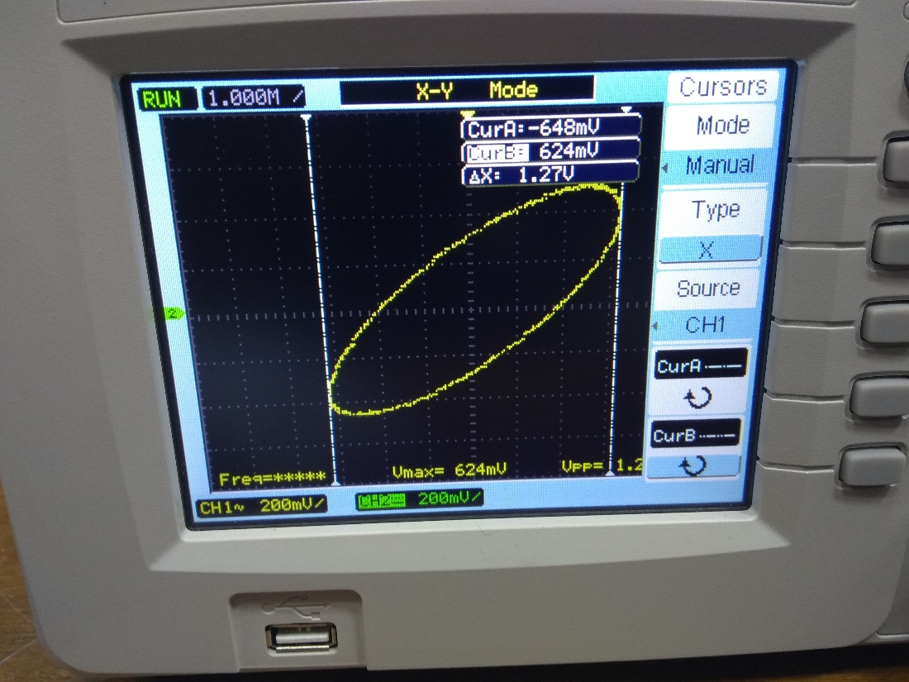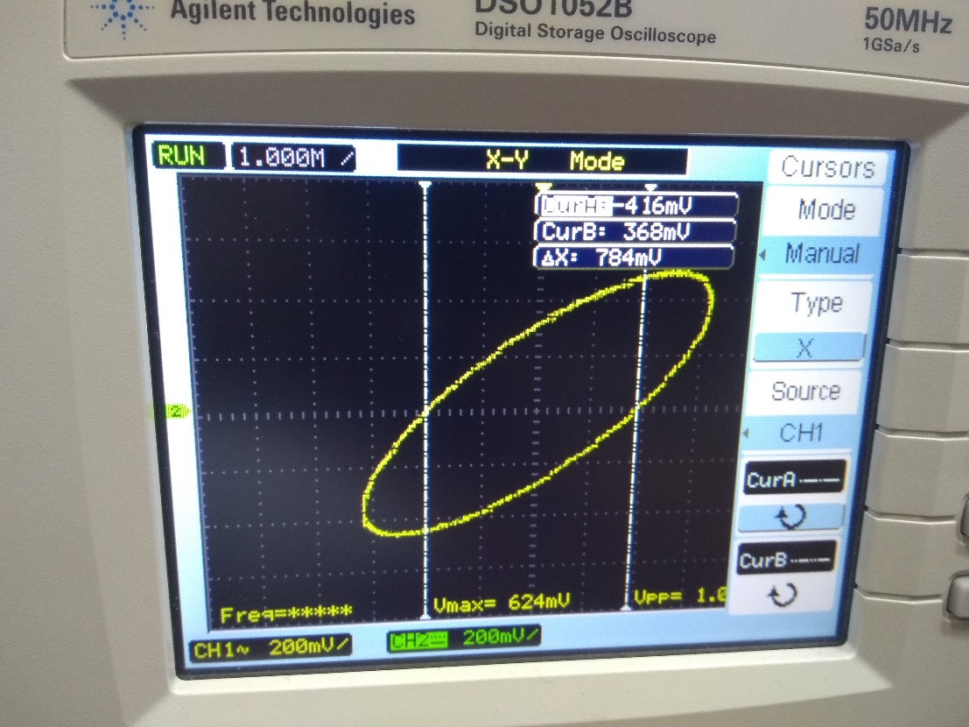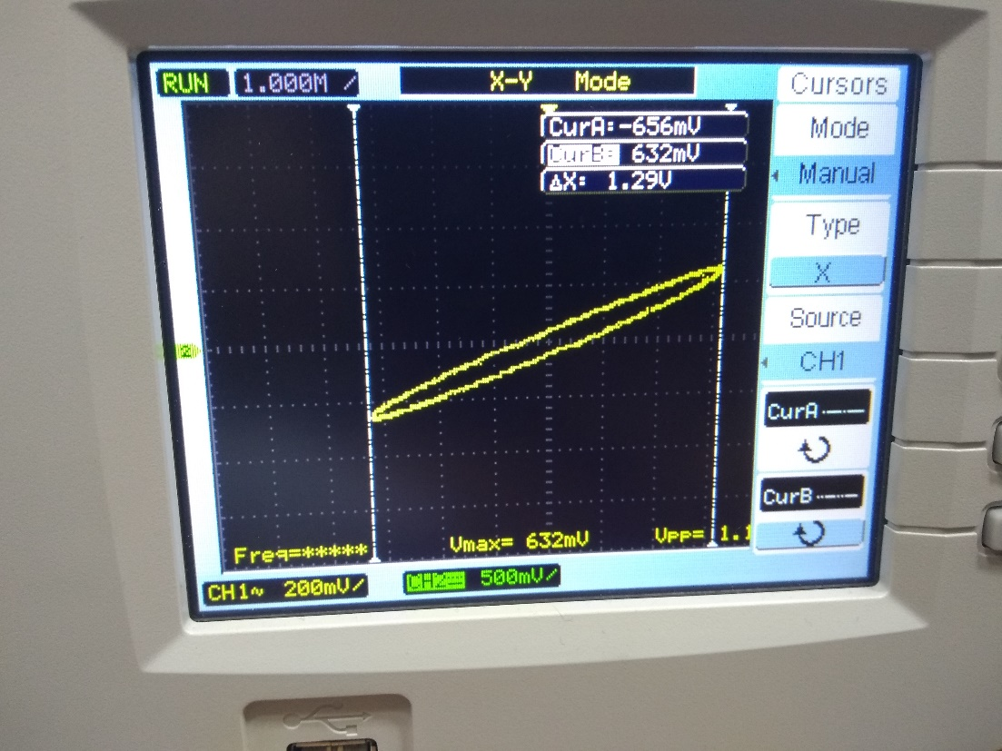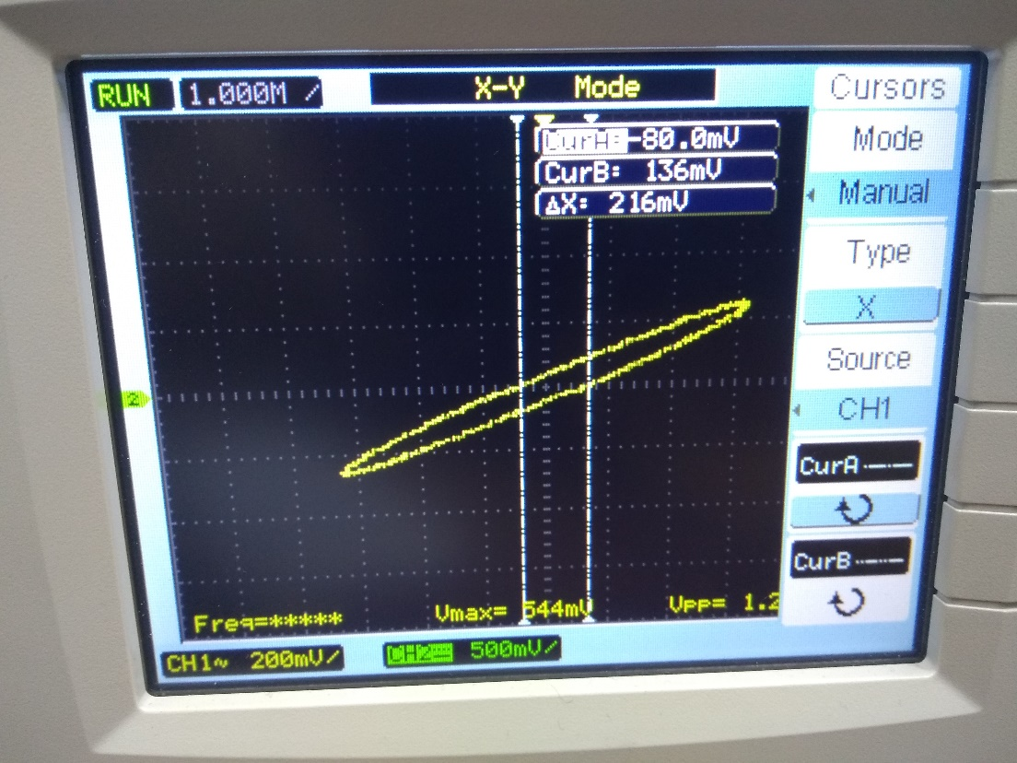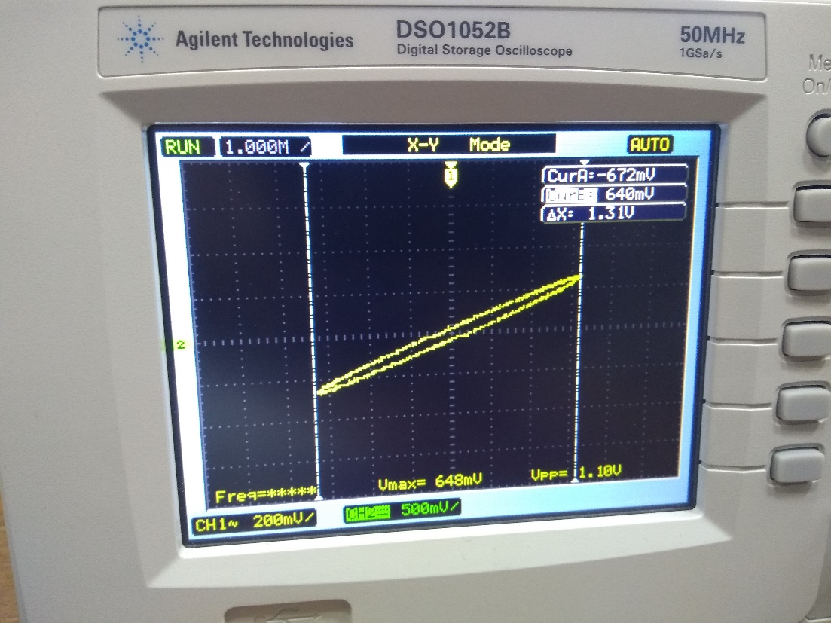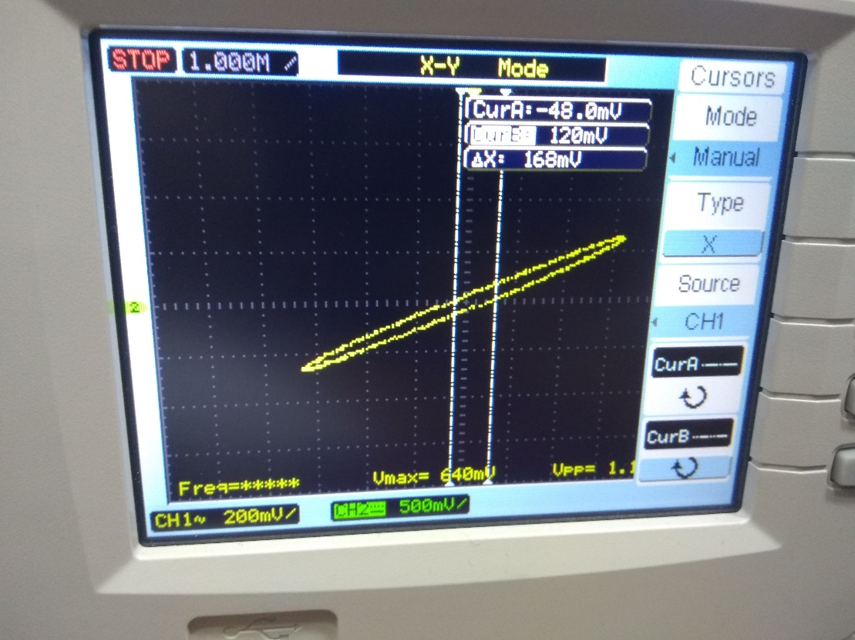

**Conclusions:**

During this experiment we familiarized with the Digital Storage Oscilloscope (DSO) and learnt how to operate it. Using it, we were able to observe the sinusoidal waveforms of the ac current (signal) that we were sending to the DSO. Then we were able to superpose two different signals and observe the types of interference, the

extent of superposition and the Lissajous pattern of the superposition, from which we were able to find the unknown frequency of the second signal. Also, we were able to find the phase difference between two signals within limits of experimental error, i.e.,

the value of phase difference calculated using values observed from the Lissajous pattern were nearly equal to those calculated directly from the input data (Capacitance and resistances).

**Sources of Error:**

1. Scale of DSO not appropriately set Loose Connections.
2. Resistance of wires not taken into account, and also giving rise to inconsistency due to increase in resistance due to heating.
3. Change in the connections while circuit is closed.

**Precautions:**

1. Make the connections neat and tight.
2. Don’t leave the switch on for long continuous periods of time.